What is Enterprise Architecture?

## Assignment: Determine the qualities needed to become EA in your organization

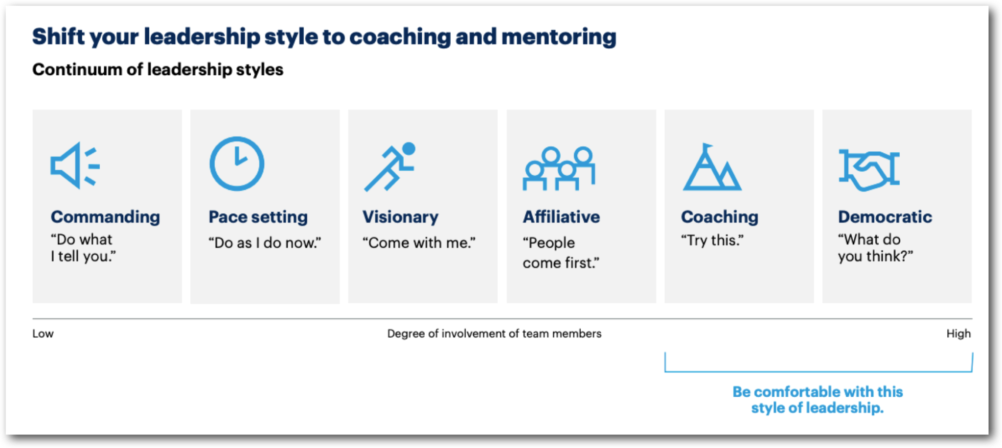

Enterprise Architecture (EA) is a discipline that focuses on aligning an organization's business strategy, processes, information, and technology in a holistic manner. It provides a blueprint for the design, implementation, and management of an organization's enterprise-wide structure and capabilities. The goal of enterprise architecture is to enable effective decision-making, enhance business agility, optimize resource utilization, and drive digital transformation.

To determine the qualities needed to become an Enterprise Architect (EA) in your organization, you can consider the following aspects:

* Technical Expertise: EAs should have a strong technical foundation and deep understanding of various technologies, platforms, and architectural frameworks relevant to your organization's industry and environment. They should stay updated with emerging technologies and trends.
* Business Acumen: EAs must possess a solid understanding of the organization's business model, goals, and industry dynamics. They should be able to translate business strategies and requirements into architectural solutions that support the organization's objectives.
* Strategic Thinking: EAs need to think strategically and have a long-term perspective. They should have the ability to envision future states, identify opportunities, and develop roadmaps that align with the organization's vision and strategic goals.
* Analytical and Problem-Solving Skills: EAs should be skilled in analyzing complex problems, assessing options, and making informed decisions. They should have the ability to break down complex issues into manageable components and provide innovative solutions.
* Communication and Collaboration: EAs must have excellent communication skills to effectively interact with stakeholders at all levels, including executives, business managers, technical teams, and vendors. They should be able to articulate complex technical concepts in a clear and understandable manner.
* Leadership and Influencing: EAs should be effective leaders who can drive change and influence decision-making. They should possess strong interpersonal skills and the ability to inspire and motivate others toward a common vision and goals.
* Systems Thinking: EAs should have a holistic mindset, understanding the interdependencies and relationships among various components of the enterprise. They should consider the broader ecosystem and the impact of architectural decisions on the organization as a whole.
* Adaptability and Continuous Learning: EAs need to be adaptable and open to change, as the business and technology landscapes evolve rapidly. They should have a passion for continuous learning, staying up-to-date with industry best practices, and expanding their knowledge and skills.
* Governance and Risk Management: EAs should have a strong understanding of governance frameworks, compliance requirements, and risk management practices. They should ensure that architectural decisions align with organizational policies, security standards, and regulatory constraints.
* Relationship Building: EAs should build and maintain relationships with stakeholders, fostering trust and collaboration. They should actively engage with business units, IT teams, and external partners to gather input, address concerns, and promote the value of enterprise architecture.